PROJECT REPORT

# DATA COMMUNICATION AND NETWORKING

**BSCS 4A SPRING 2024**

# Submitted by:

Tooba Tanvir (01-134222-160)

Syeda Zahra Ali (01-134222-154)

Ebad Afridi (01-134222-040)

# CONFIGURING A WIRELESS LAN (WLAN)

# Introduction

In this project, we designed a university network using Cisco Packet Tracer, focusing on wireless connectivity to enhance mobility and efficiency. The network spans across academic buildings, hostel blocks, and common areas like the library. Key components include routers, switches, servers, wireless access points, and various end devices such as PCs, laptops, and smartphones. Our aim was to provide seamless internet access, data sharing, and web services to students and staff, ensuring a reliable and secure communication system within the university. This design demonstrates the integration of wireless technology in a campus setting to support modern educational needs.

## Importance of topic:

Designing a university network using wireless systems is crucial for enhancing mobility, allowing students and staff to access the network from anywhere on campus. It improves accessibility by providing easy and reliable internet connections in various campus locations. Centralized servers ensure efficient resource management and seamless communication. The wireless network is scalable, cost-effective, and promotes better collaboration through easy access to shared resources and online platforms. This modern approach supports the dynamic needs of educational institutions.

## Objective:

1. Design a wireless network for the university using Cisco Packet Tracer.

2. Ensure easy and reliable internet access across campus.

3. Set up DNS, email, and web servers for efficient communication.

4. Provide secure and dependable network connections.

5. Make the network scalable for future growth.

6. Enhance collaboration and data sharing among students and staff.

## Tool used:

Following tools are used in preparation of project:

* Cisco Packet Tracer.

## Why we used Cisco Packet Tracer:

Cisco Packet Tracer is used because it provides a virtual environment for learning and practicing networking concepts, allowing users to design, simulate, and troubleshoot networks without needing physical hardware. It’s an educational tool that supports a wide range of devices and protocols, making it ideal for both students and professionals.

# Features and Functionalities

The features and functionality of the university network project include:

1.Wireless Connectivity: Ensures seamless internet access across academic buildings, hostels, and common areas.

2. Centralized Servers: Includes DNS, email, and web servers for efficient communication and resource management.

3. Device Integration: Supports various devices like PCs, laptops, and smartphones, enhancing user mobility.

4. Secure Networking: Implements console passwords and SSH protocols for secure data transfer.

5. Scalability: Designed to accommodate future growth and additional devices.

6. Network Segmentation Divides the network into campus and hostel areas for organized and efficient traffic management.

**AIM:**

The aim of this project is to design the topology of the university network using the software Cisco Packet Tracer

with the implementation of wireless networking systems

**DEVICES USED IN PROJECT:**

This university network consists of the following devices:

1. Router (1941)
2. Switches (2960-24TT)
3. Email server
4. DNS server
5. WEB server (HTTP)
6. Wireless Device (Access Point)
7. PCs
8. Laptops
9. Smartphones

**Parts:**

The design includes the following parts of the University:

* Hostel Blocks:
  + Girls Block and Boys Block
* Academic Blocks:
  + AB1 and AB2
* Dome Building and Library
* IT Consulting

**Project Statement:**

In this project, we defined a simulation of campus networks based on wireless networking. The network is divided into two sets: one for the campus area and the other for the hostel area. The major aim of this project is to show the wireless connectivity that is used in universities to make the network efficient and mobile at the same time. Mobility is the major concentration of this project. To provide equal functionality to all the users (college staff and students), we have added DNS, Email, and HTTP servers for the maximum utilization of resources. Hence the campus network provides different services such as connecting the user to the internet, data sharing among users (students, teachers, and different university members), accessing different web services for different functionalities, so it needs wireless networking for smooth processing.

**Devices used and Quantity.**

|  |  |
| --- | --- |
| Network Device | Quantity |
| Router (1941) | 3 |
| Switches (2960-24TT) | 3 |
| EMAIL server | 1 |
| DNS server | 1 |
| WEB server (HTTP) | 1 |
| Wireless Device (Home Router) | 7 |
| Laptops | 10 |
| Smartphones | 2 |

**Implementation and Flow Diagram:**

● To design the wireless network of the university we initially started by placing the core devices into the frame as mentioned in the layout.

● Firstly, we placed the main router at the center of the university outline, which was further connected to the server switch using the gigabit ethernet port with copper straight-through cable and sub routers (campus router and hostel router) using the serial port with serial DCE cable at the hostel area and campus area respectively.

● The server switch was further connected to the EMAIL, DNS, and WEB servers respectively.

● Campus router was connected to the campus switch which was further connected with Home Router of the academic block (OC Lab 1, OC Lab 2, OC Lab 3) and library.

● The wireless access points were then connected to computing devices (PCs, laptops, and smartphones).

● Similarly, the hostel router was connected to the hostel switch which was further connected with the Home Router of boys’ hostel and girls’ hostel.

● The wireless access points were then connected to the computing devices (PCs, laptops, and smartphones), every area has a dedicated access point which can only relate to the help of a password.

● All these connections are made through ethernet ports (gigabit ethernet and fast ethernet) using copper straight-through cables.

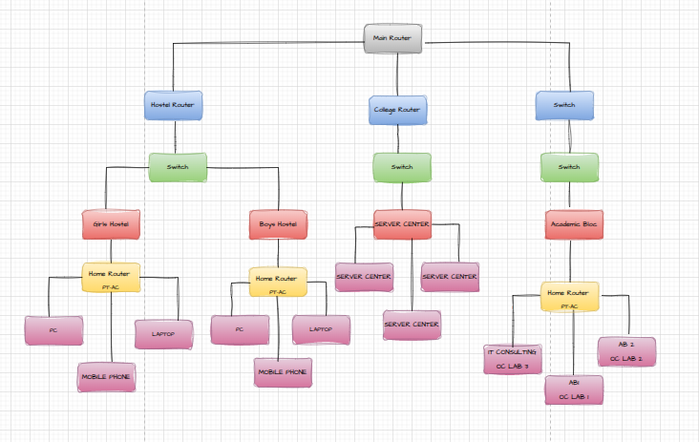

**NETWORKS:**

* Academic Blocks

**OC LAB 2**

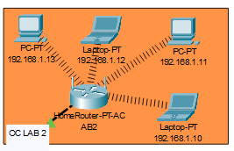

IP Address are as follows

192.168.1.10- Laptop

192.168.1.11- PC

192.168.1.12- Laptop

192.168.1.13- PC

Subnet Mask- 255.255.255.0

Default Gateway- 192.168.1.1

DNS Server- 192.168.2.3

.

**OC LAB 1**

IP Address are as follows

192.168.1.14- Laptop

192.168.1.15- PC

192.168.1.16- Laptop

192.168.1.17- PC

Subnet Mask- 255.255.255.0

Default Gateway- 192.168.1.1

DNS Server- 192.168.2.3

**LIBRARY**

IP Addresses are as follows

192.168.1.5- PC

192.168.1.6- PC

Subnet Mask- 255.255.255.0

Default Gateway- 192.168.1.1

DNS Server- 192.168.2.3

**OC LAB 3**

IP Addresses are as follows

192.168.1.7- Laptop

192.168.1.8- PC

192.168.1.9- PC

Subnet Mask- 255.255.255.0

Default Gateway- 192.168.1.1

DNS Server- 192.168.2.3

* **HOSTELS**

**BOYS HOSTEL**

IP Addresses are as follows

192.168.3.6- PC

192.168.3.7-Laptop

192.168.3.8- PC

192.168.3.9- Smartphone

Subnet Mask- 255.255.255.0

Default Gateway- 192.168.3.1

DNS Server- 192.168.2.3

.

**GIRLS HOSTEL**

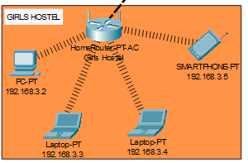

IP Addresses are as follows

192.168.3.2- PC

192.168.3.3-Laptop

192.168.3.4- PC

192.168.3.5- Smartphone

Subnet Mask- 255.255.255.0

Default Gateway- 192.168.3.1

DNS Server- 192.168.2.3

**System Config**

**Final Topology**

**Conclusion**

In this project, we designed a University Network using Cisco Packet Tracer that uses a networking topology implemented using servers, routers, switches, and end devices in multiple area networks. We have covered all the necessary features that are required for a network to function properly. We have included a DNS server and a web server for establishing a smooth communication system between different areas of our network and specifically for communication between students and teachers. We have included an email server to facilitate intra-university communication through emails within the domain. We have used console passwords and ssh protocol to ensure a safe and secure transfer of data

[Optimizing Wireless Local Area Network (WLAN) Configuration | Slidesgo](https://slidesgo.com/editor?template=9c2011ff-a8b5-40ed-9a0a-79ea634d361e&aipresentation=%7B%22topic%22%3A%22Configuring+Wireless+Local+Area+Network+%28WLAN%29%22%2C%22tone%22%3A%22Formal%22%2C%22language%22%3A%22English%22%2C%22vector%22%3A38139%2C%22slides%22%3A10%7D&lang=en#rs=landing-ai-slidesgo)